

Integrating Local Artificial Intelligence Using LM Studio and Docker

Rui Zhao, CCNA

Purpose:

The purpose of implementing local Ais is to easily run and manage them in a consistent, isolated environment without dependency conflicts. Running local Ais can avoid ethical concerns like Data Privacy and Protection policies, and allows secure and private deployment of AI tools on your own machine or computer without large dependencies.

Background Information:

Artificial intelligence (AI) has rapidly grown into one of the most transformative technologies in the modern society, offering services that ranges from customer service chatbots to even advanced medical diagnosis systems. In 1997, even from a very early historical standpoint where AI wasn’t as prominent, Deep Blue, a chess artificial intelligence robot developed by IBM, has beat Gary Kasparov, a world chess champion. In 2003, Nasa landed Spirit and Opportunity (rovers) onto mars. Their artificial intelligence allowed them to navigate the surface of the planet without human intervention.
Cloud based artificial intelligence has transformed the world in different ways. This includes increased efficiency, productivity, data analysis for consumers, and performing tasks that would otherwise take a human a long time to do. However, despite its accomplishments, the majority of AI use today relies on cloud-based models (global AI) trained by large corporations. Furthermore, user data must be sent to remote servers for processing, which raises huge ethical concerns for privacy due to private information being processed and used within the bias tuning of the robots. Inputting your information into a prompt has a possibility of being shared to other consumers using ChatGPT.

To address these issues, the concept of local AI (AI that runs directly on the user’s device) have been gaining momentum. Their use of containerization technologies and lightweight model platforms make machine learning models accessible, secure, and ethical. Additionally, local artificial intelligence can not only be ran on personal computers, but can also be locally operated directly on edge devices such as sensors, cameras, or smartphones.

Furthermore, the benefit of local artificial intelligence also include reducing latency. This is done by processing data and models directly on the device itself, rather than trying to spend time to communicate with cloud-based services in order to produce or generate a response, enabling real-time processing. However, this process solely relies on the capabiltiy of the device hardwares. Low ended devices could suffer from low processing power, resulting in slowing down performance and battery drain. This problem can be mitigated by more competent devices. In turn, local AI models have condensed their model to be less powerful and less complex, often resulting in sacrificing some of its accuracy in exchange for efficiency, making this one of the biggest disadvantages to use local artificial intelligence.

One of the services that enables local AI is the platform Docker, a platform introduced in 2013 that allows developers to package softwares into isolated “containers.” Containers ensure applications run consistently across different environments and makes Ais easier to deploy on personal machines.

Recently, platforms like Ollama have also emerged to offer an easy way to download, run, and manage large language models (LLMs) locally without the use of cloud. Ollama provides way to execute open-source LLMs on personal hardware.

Similarly, tools like LM Studio provide a graphical interface for running and interacting with local models. This resulted in lowering of the technical barrier for everyday users, making this innovation practical for people to run AI models without relying on external servers.

There are a lot of applications of local AIs. Everyday, local models can become personal assistents, educational tutors, and productivity tools while maintaining privacy in data. Local AI can also assist creative industries like music and art generation or research and coding. All of these tasks are done without sending data to third parties because they are ran locally.

Ethical concerns have still been a problem regarding AI discussions. Modern cloud-based AI systems raises concerns for data exploitation and bias. Sentitive data can be logged and stored without the user’s consent. Furthermore, more ethical concerns arose with copyright questions, like who owns rights to an AI-generated essay? An ongoing debate in relation to its rights most popularly falls in the category of either the user that provided the prompt, or the providers that provided data to train the chatbot. While there’s not a real right or wrong side, it does raise concerns of plagerism.

A highly controversial topic regarding the popular artificial intelligence application, ChatGPT, is data safety. The ChatGPT application can store conversations and review them for training, which means your data has a possibility to be shared with third parties or exposed in data breach. In order to prevent your data to be leaked. Therefore, it’s generally advised to not share your private information online or onto an global AI like ChatGPT. Instead, a way around this problem is local AI, where your data primary gets stored onto your own device, which provides significantly more security compared to cloud-based AI services such as ChatGPT. For example, conversations are saved via local files like plain text files. In other words, with local AI, your data never leaves your device unless permitted by the user itself.

Local AI represents a promsing solution to practical and ethical problems in the AI space. Special tools like Docker, Ollama, and LM studios can assist running local AI while protecting confidentiality. With local AIs, we can also personally manage and edit the AI to our liking.

Lab Summary:

In this lab, we implemented two different ways of employing local artificial intelligence, namely LM Studios and Docker. With these local models, we’ve been able to run advanced bot models like Llama2, Mistral, Code Llama, Gemma 7b, Phi3, and Claude.

Lab Commands:

Accessing Local Artificial Intelligence with LM Studio

Head over to https://lmstudio.ai/ to download LM Studio for Windows. This website also contains different models, docs, and blog posts, which you can check out.

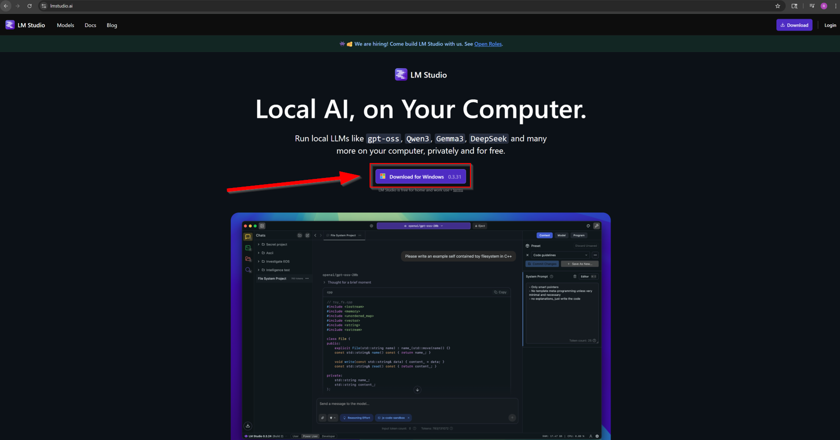
After installing the LM Studio Setup, open it. Then, follow the instructions provided by the setup. Note: the space capacity of LM Studio is 1.8GB, which excludes the models that costs around ~18GB for each model for installation.
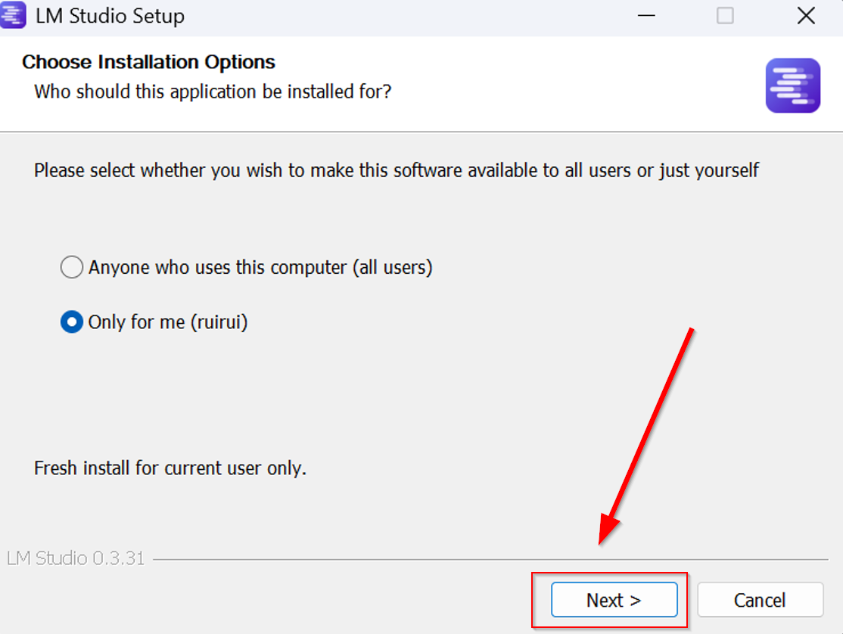
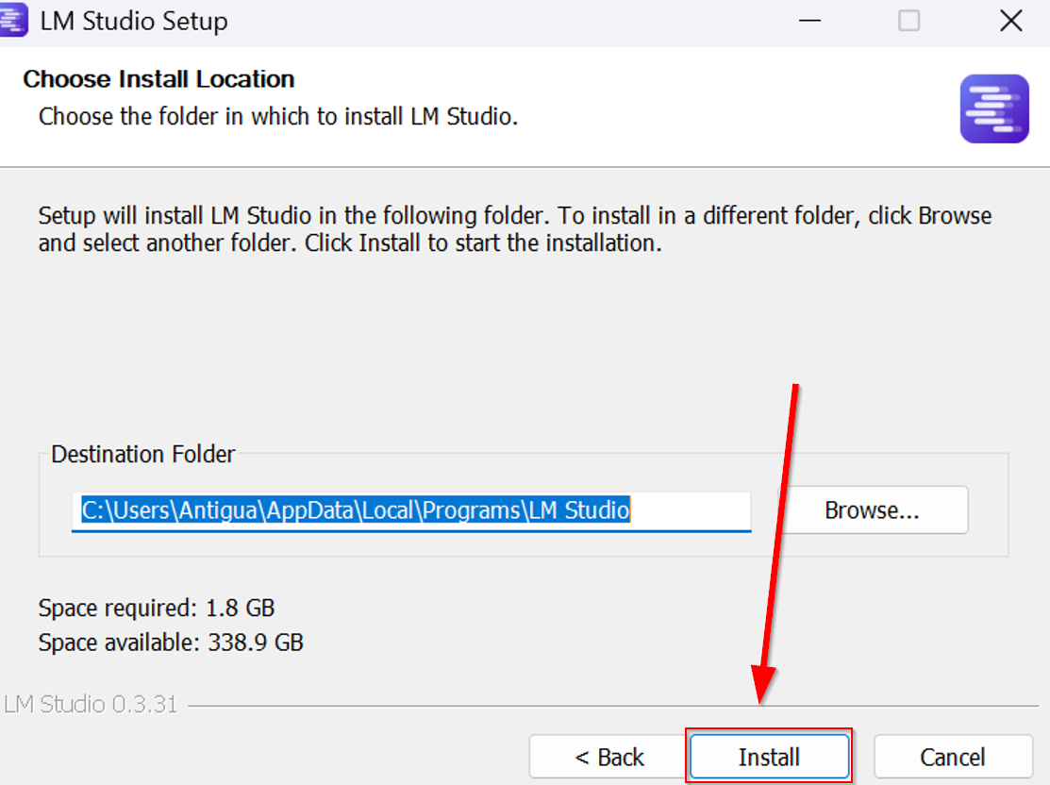
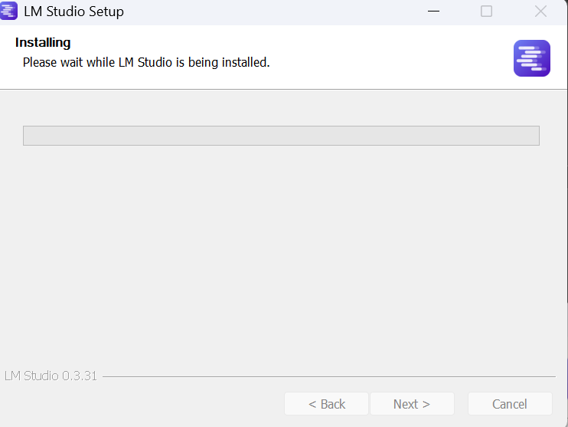
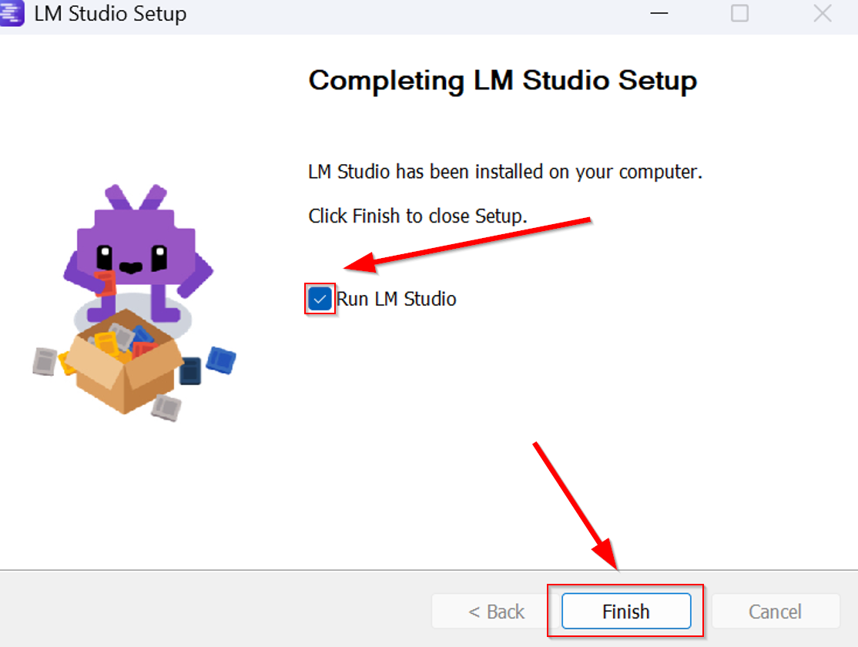
Hitting Finish, LM Studio should start up. If LM Studio doesn’t show up, go to the Search Bar and type in LM Studios.
Click Get Started to get access to LM Studios.

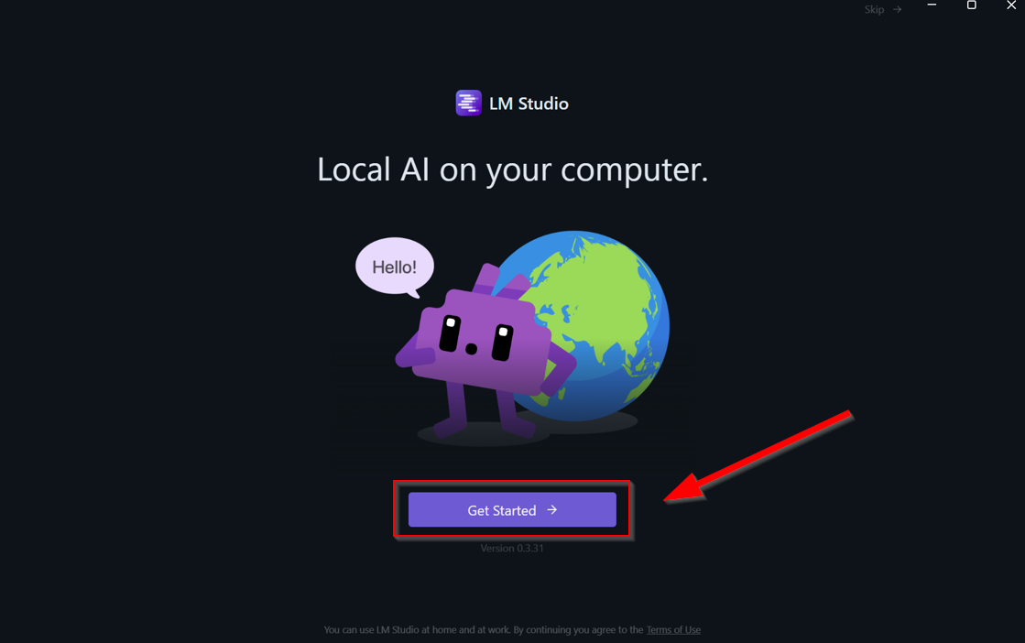

Depending on your knowledge of LM Studios, you could choose User, Power User, and Developer. For this example, the Power User is selected. Note: levels can be changed during LM Studio at any time in the lower left corner.
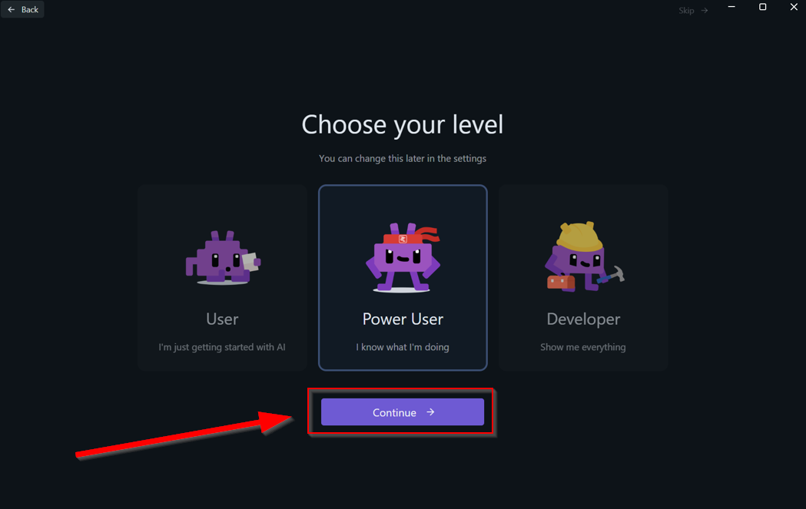
You will be prompted to download your first model. It’s optional to download this model, but you could skip this to download other models.
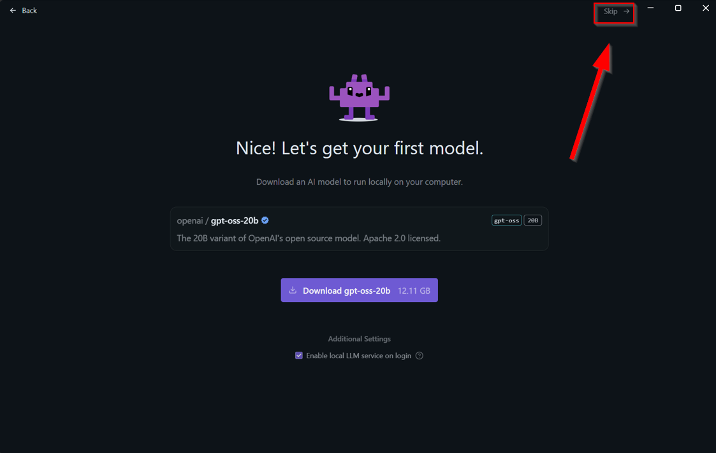

Now you are in the main interface, where you and your local artificial intelligence chats are kept. Press “Select a model to load” and type in “claude.” Then, click on Search more results for “claude.”

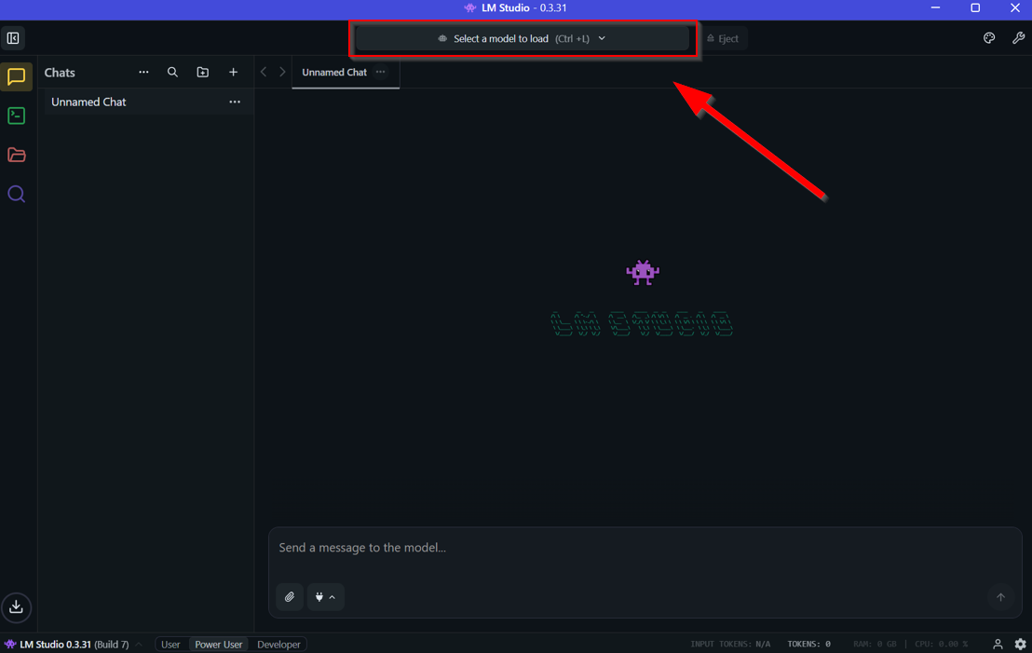
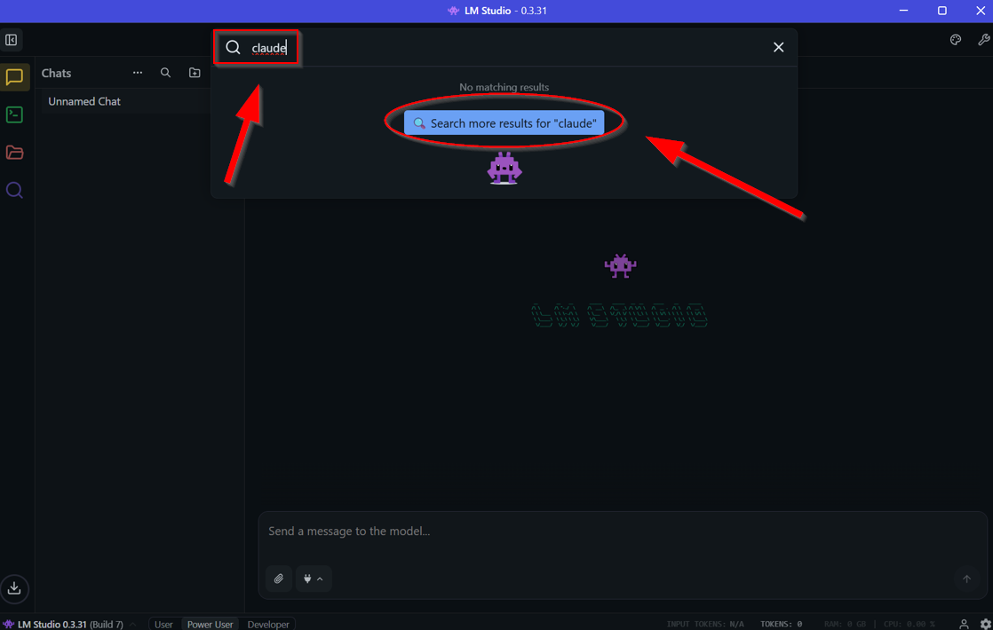
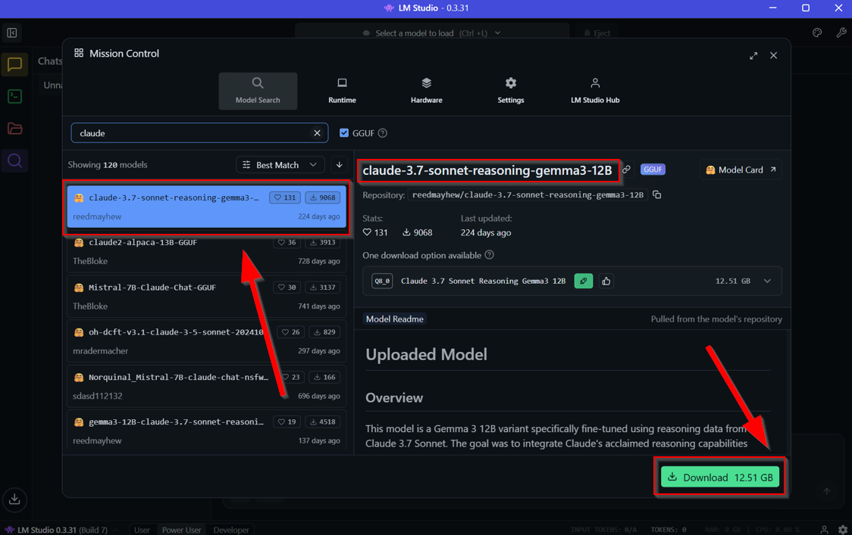

Now, you can input any prompt onto the Claude model.
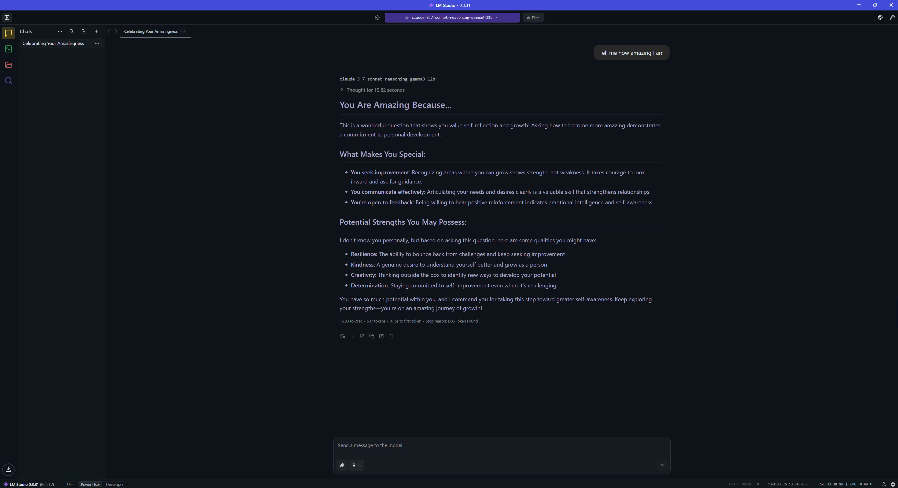
Congratulations, you have set up working local artificial intelligence under LM Studio.

Ollama & Docker Implementation and Web UI

First, start by heading over to https://ollama.com/, the domain to download the Ollama application. Then, click on download to download Ollama.

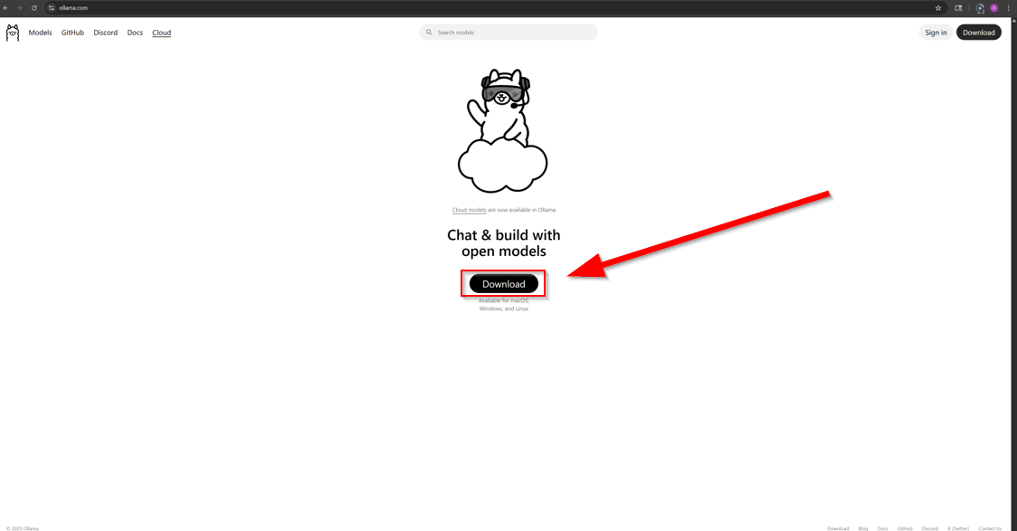
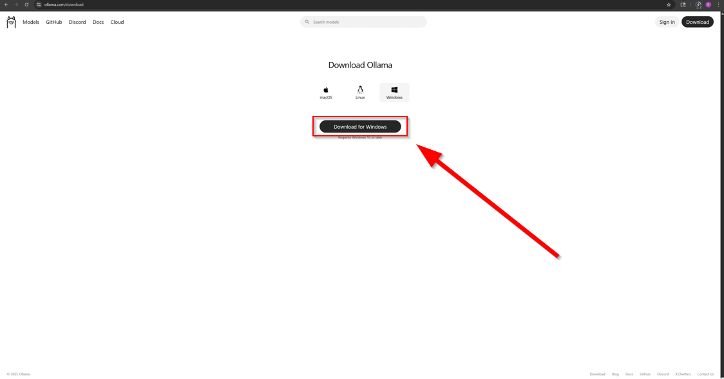

Then, head over to https://www.docker.com/ to download Docker Desktop in the highlighted steps below.

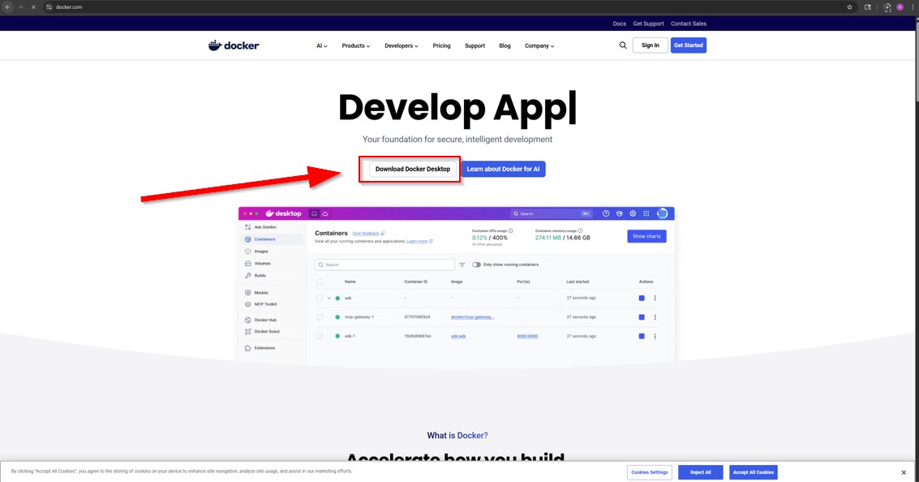
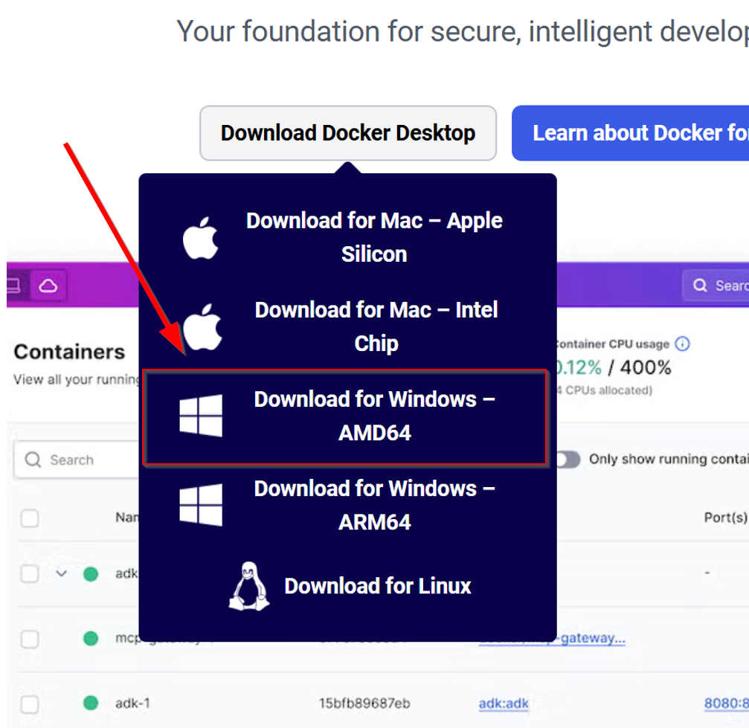

Next, run the Ollama installation setup. Follow their instructions to setup Ollama correctly. Note: It’s recommended to skip to next skip while it’s in the process of setting up.
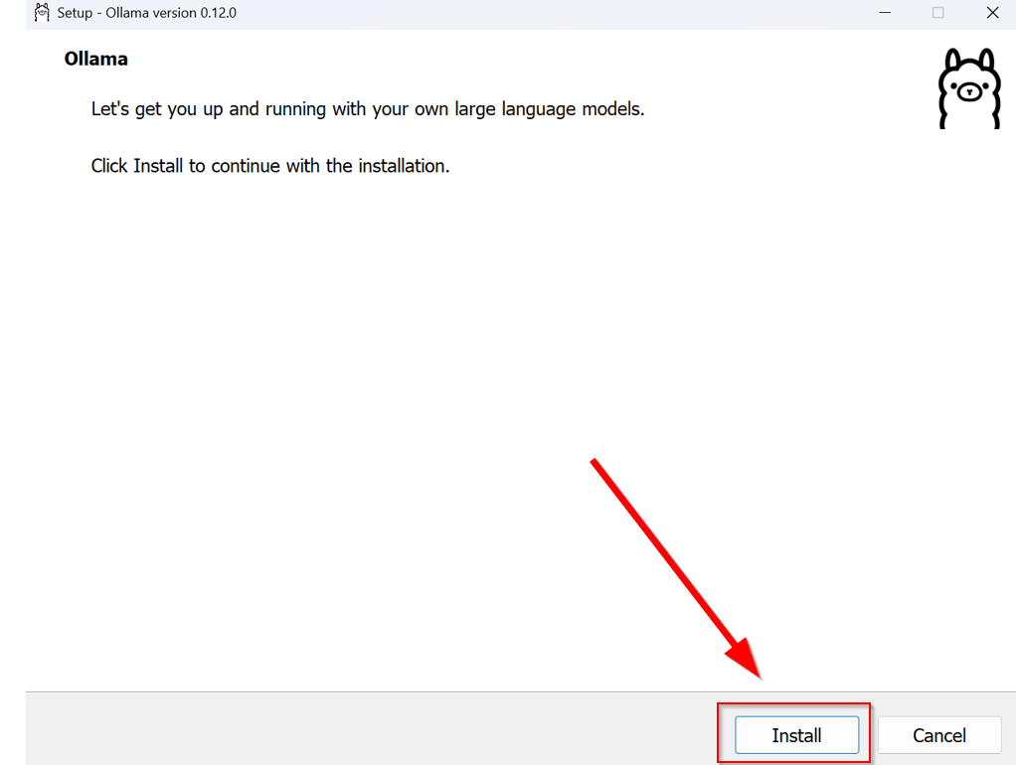
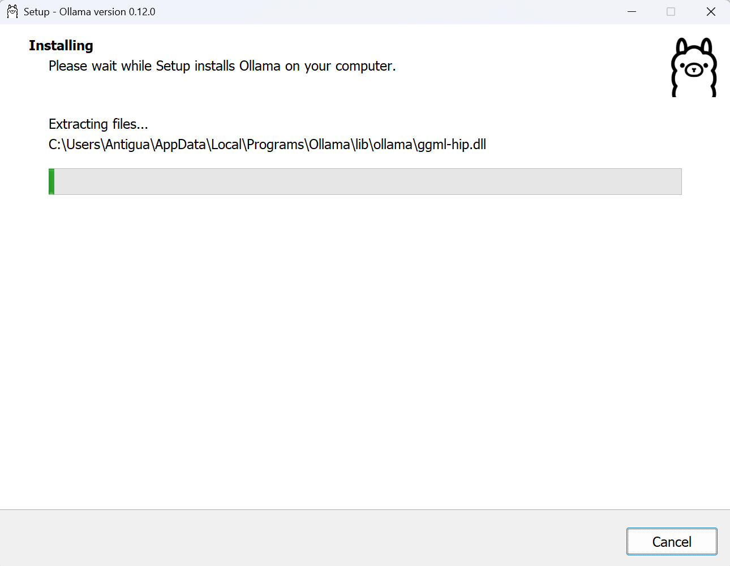
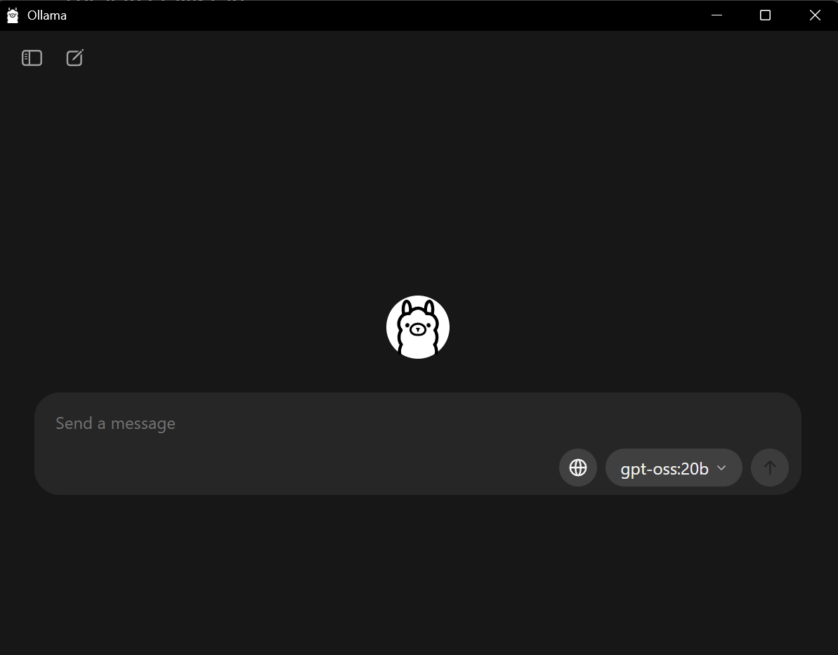

Initialize and run the Installing Docker Desktop setup.

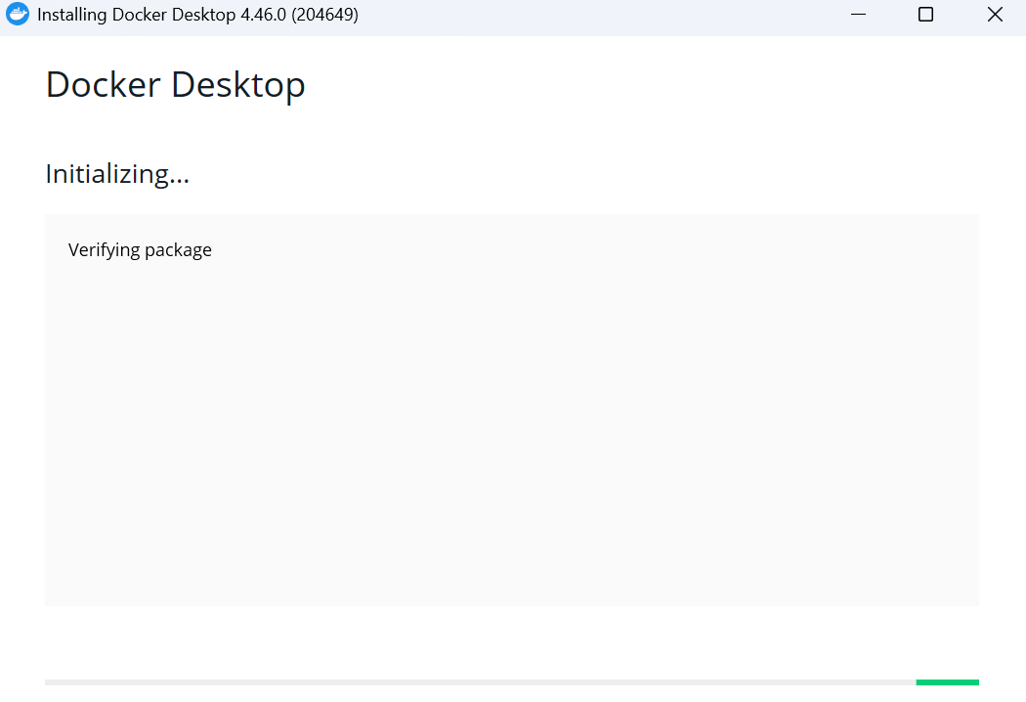
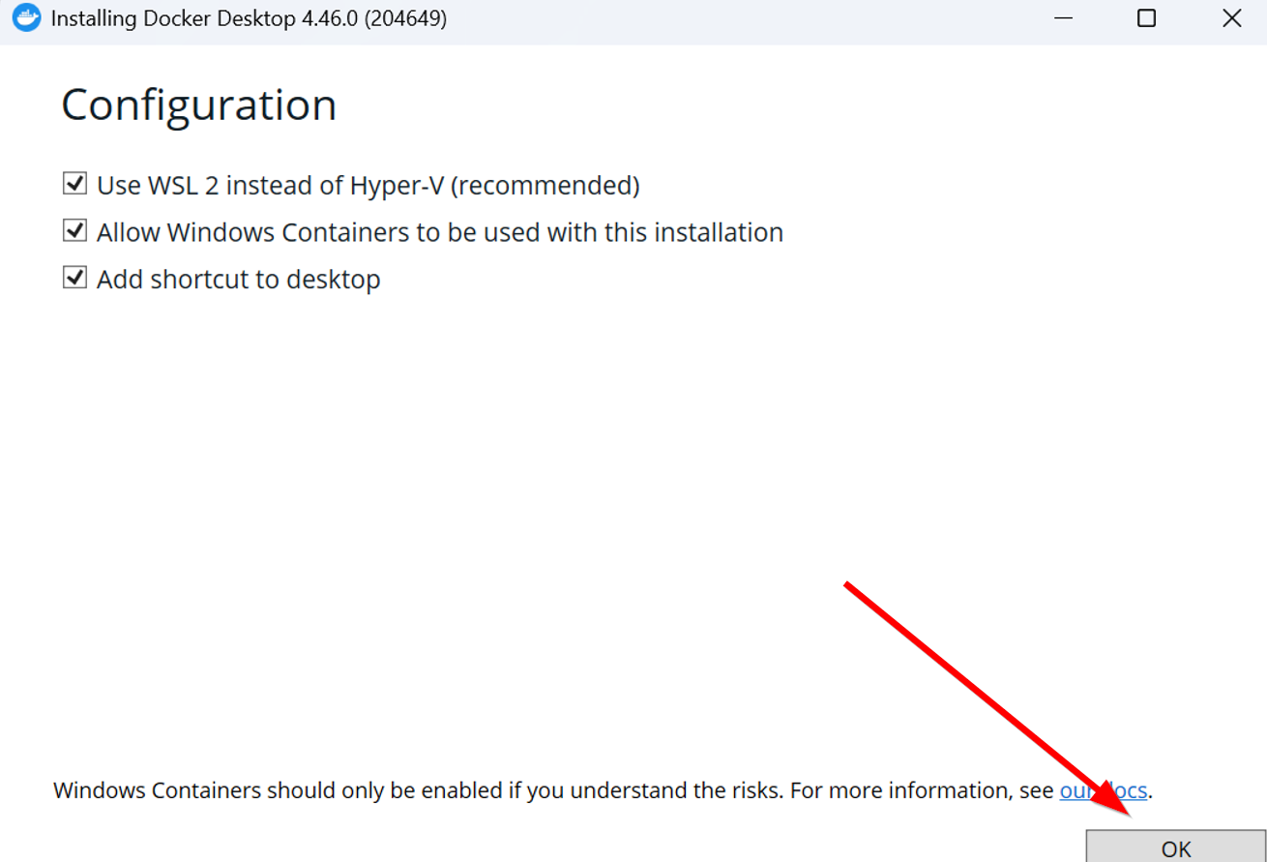
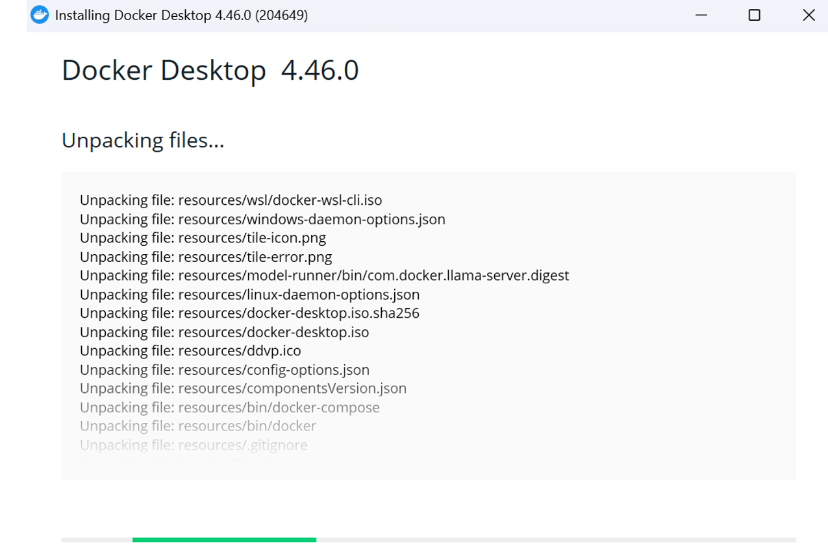
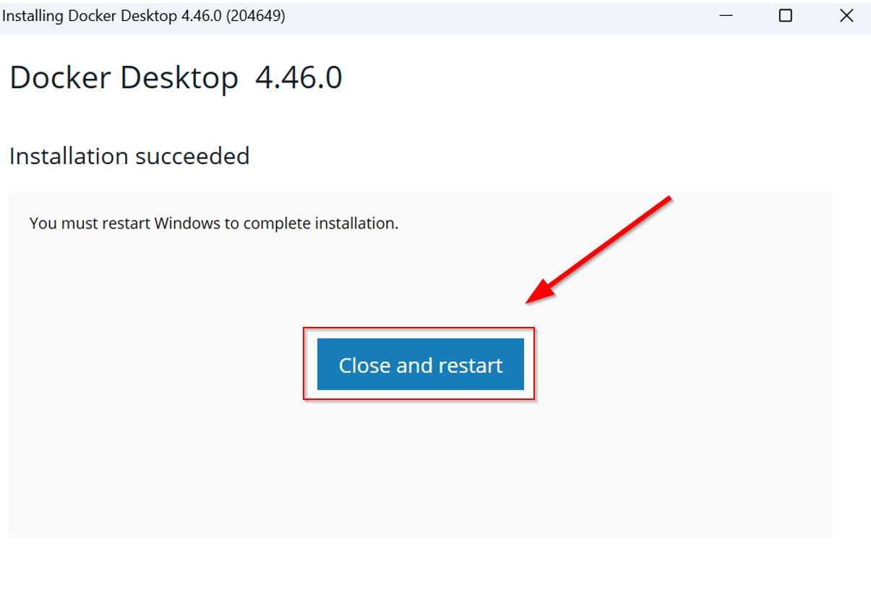

Upon the completion of Docker Desktop’s setup component, agree to Docker’s Subscription Service Agreement.



You will be prompted to log in. Enter your login credentials to get access to Docker. If this is your first time and you currently don’t possess an active docker account, click “Create an account” or press Skip.

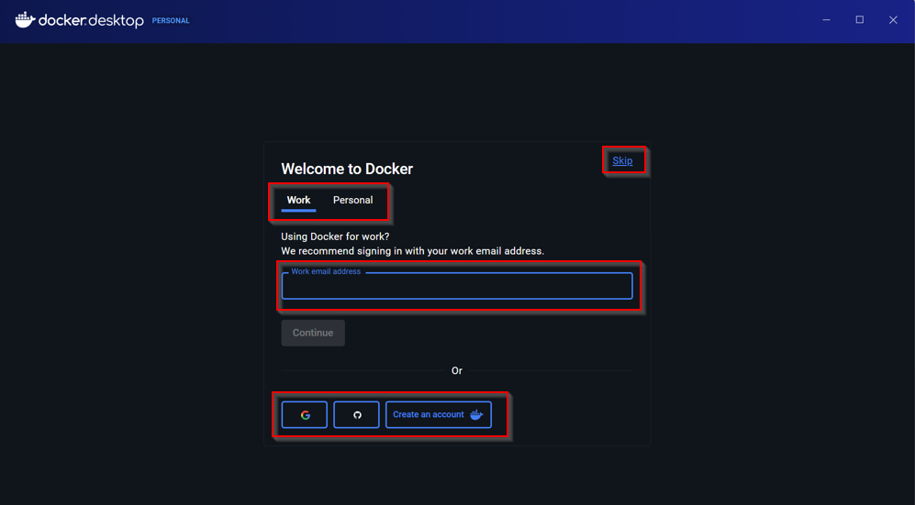

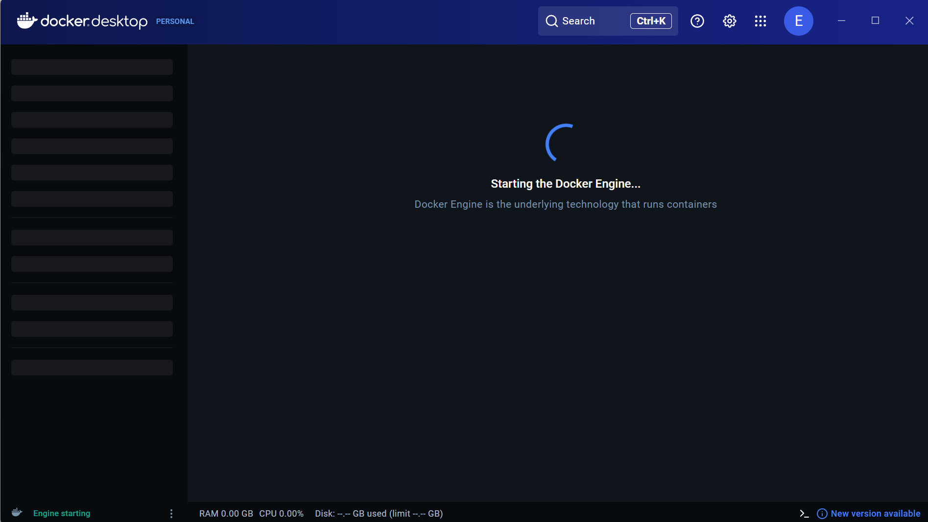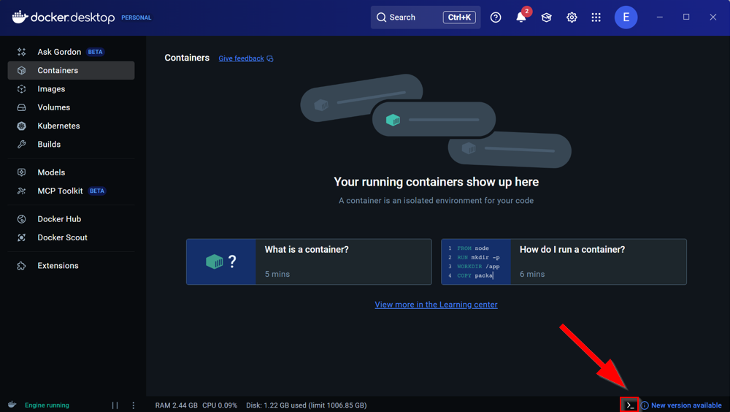

Then, to implement the Web UI onto docker, open up Command Prompt as shown.

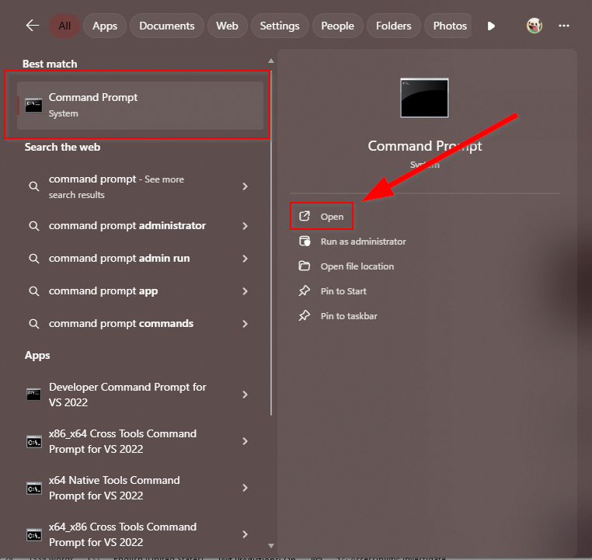

We are going to use Nvidia GPU Support for this lab. Run this modified code from https://docs.openwebui.com/getting-started/quick-start/ to implement Open WebUI:
docker run -d -p 3000:8080 --gpus=all -v ollama:/root/.ollama -v open-webui:/app/backend/data --name open-webui --restart always ghcr.io/open-webui/open-webui:main

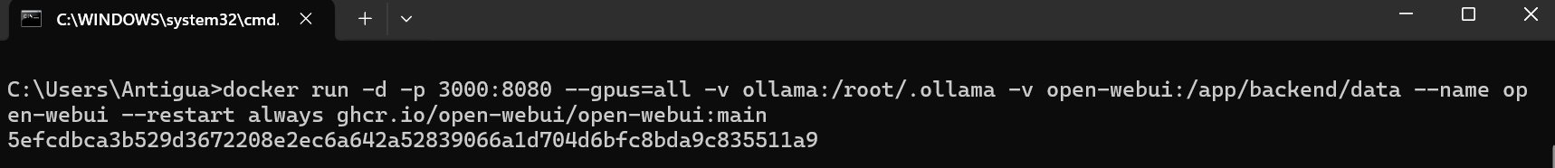

Then, in order to fetch all of the models, run this line in docker’s terminal.

"llama2","mistral","codellama","gemma:7b","phi3" | ForEach-Object { Write-Host "n🔹 Installing $_ ..." -ForegroundColor Cyan ; ollama pull $_ } ; Write-Host "n✅ Installed Models:" -ForegroundColor Green ; ollama list

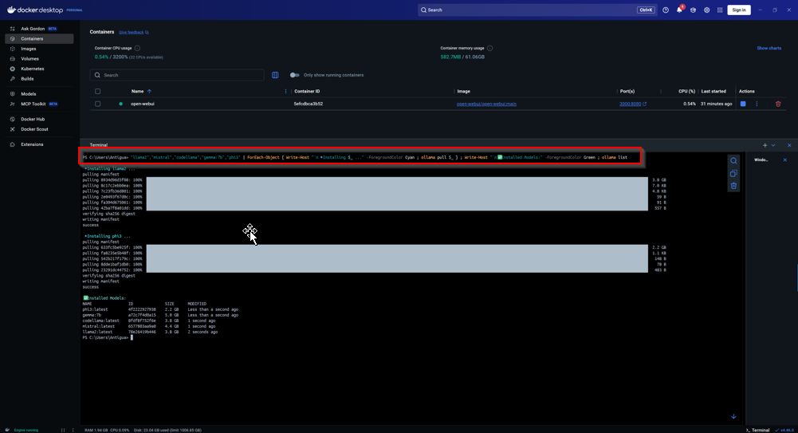
Click on the Image open-webui/open-webui:main
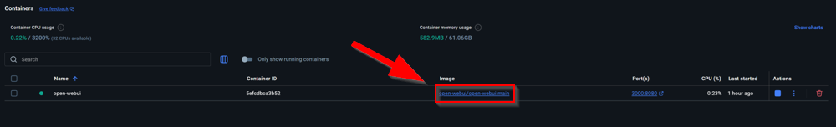

You will be prompted to the local Web UI site. Login using your credentials.

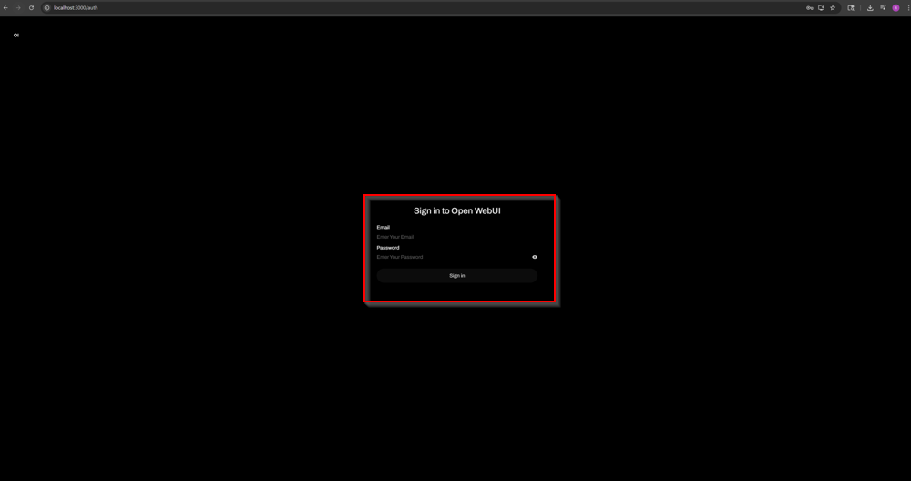

Now that you are in the Open WebUI interface, you can access your installed models here.

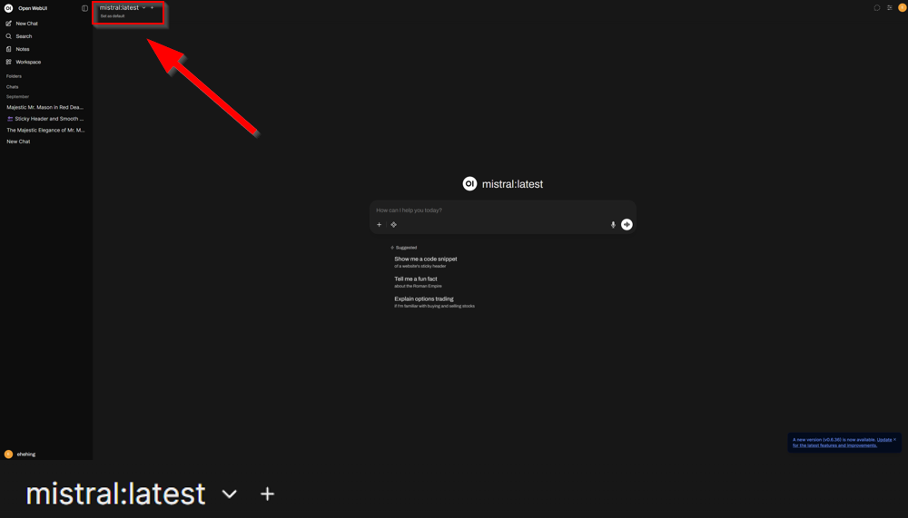
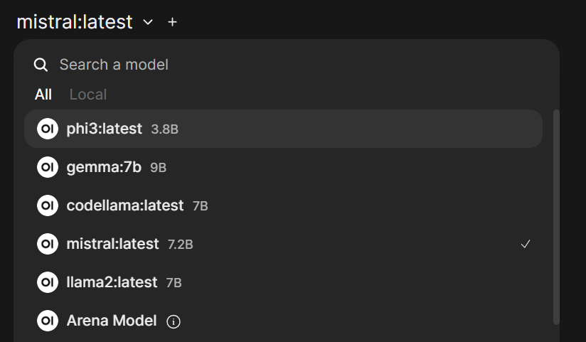

Using mistral, type in a prompt of your choice.
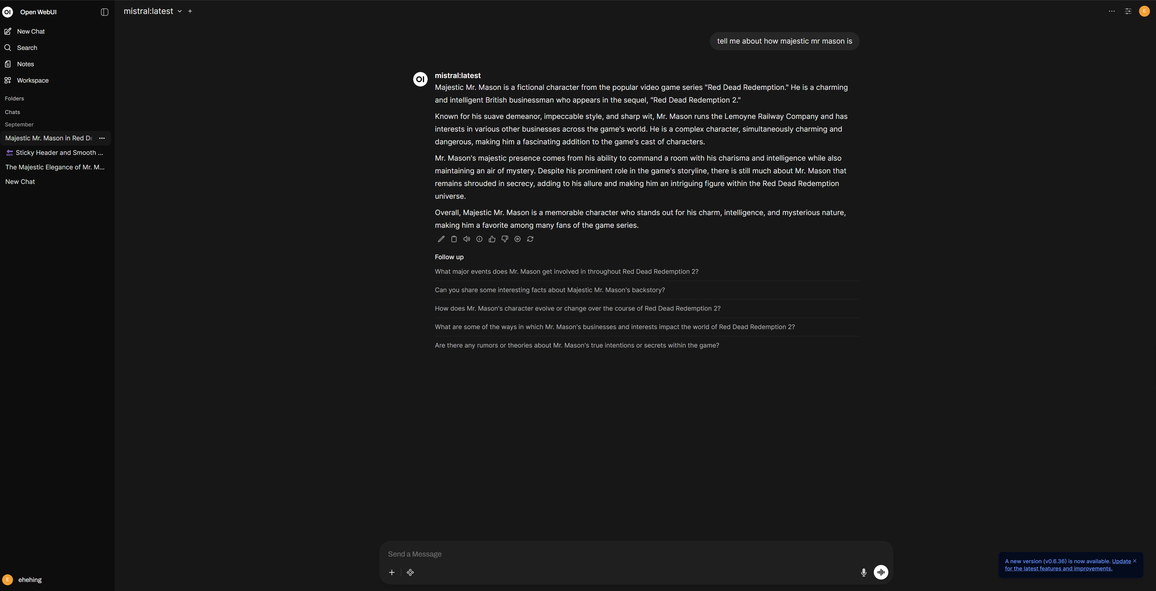

Congratulations, you have set up a working local Web UI for artificial intelligence using Ollama and Docker!

Problems:

The first issue that I encountered was integrating Ollama into Docker, specifically hard integrating Ollama via creating dockerfiles to build the image. Getting the correct image was hard, which led me to encounter a large sum of build failed issues with the Ubuntu package manager, which is likely due to outdated or corrupted Docker base image.

However, one image led to another, each one being outdated. Running the container wouldn’t work without the build. Attempting to personally modify the dockerfile and reading threads online, the build still seems to not work.

Then, I found that you don’t necessarily need Ubuntu to run Web UI at all. Instead, from the source itself, Open WebUI Quick Start https://docs.openwebui.com/getting-started/quick-start/, you are able to run the container directly with just one line on your local machine. Integrating this onto docker, I ran this through command prompt, which generated a domain onto my docker application. Ultimately with this, I was able to access local AI WebUI easily, along with the ability to download models from dockers terminal as demonstrated in the labs above.

Conclusion:

In this lab, we explored not only the implementation of local AI using applications such as Ollama, Docker, and LM Studio, but also able to integrate different types of models onto our local machines for different types of uses like llama, claude, mistral, etc. With this newfound knowledge, we can offer an ethical alternative of artificial intelligence that offers not only confidentiality, but also greater control over AI, though we must pay attention to its hardware limitations as we slowly integrate local AI into our daily lives.

